# MARKET ANALYSIS

# CUSTOMER NEED IDENTIFICATION

1. LARGE DISTANCE TO COMMUTE WITHIN THE COLLEGE  
   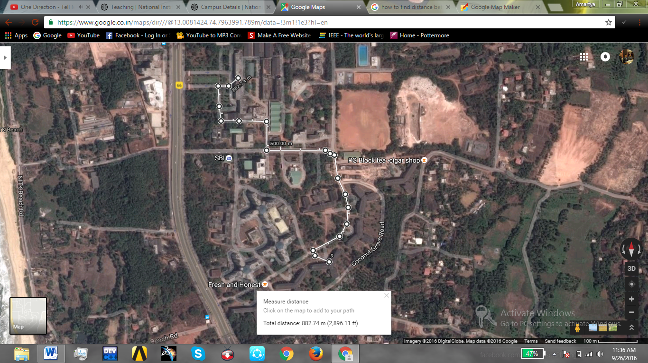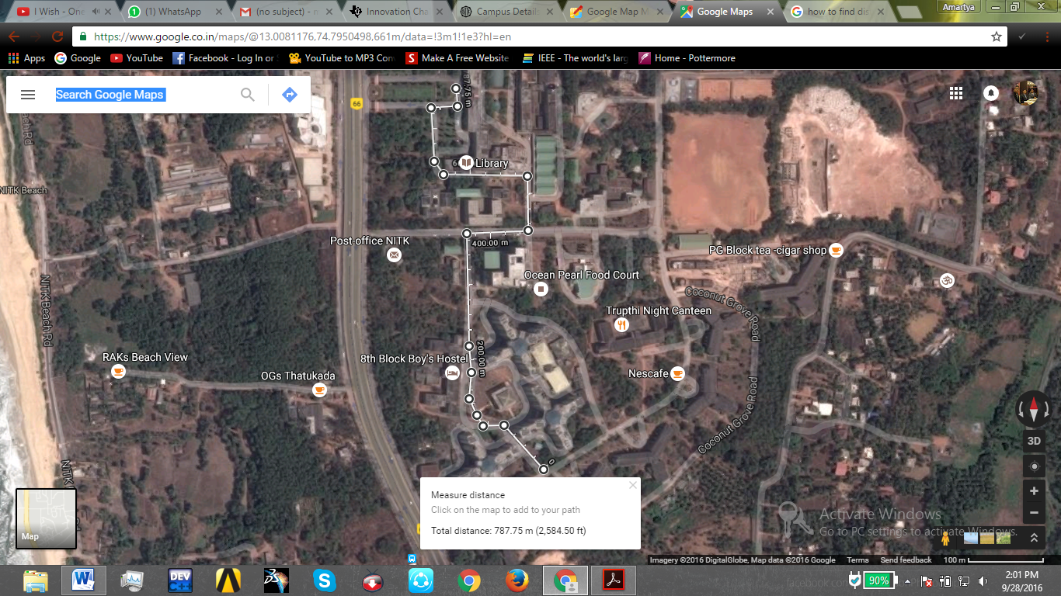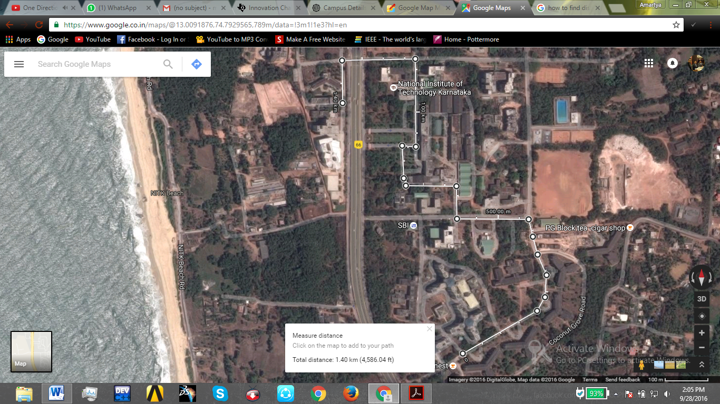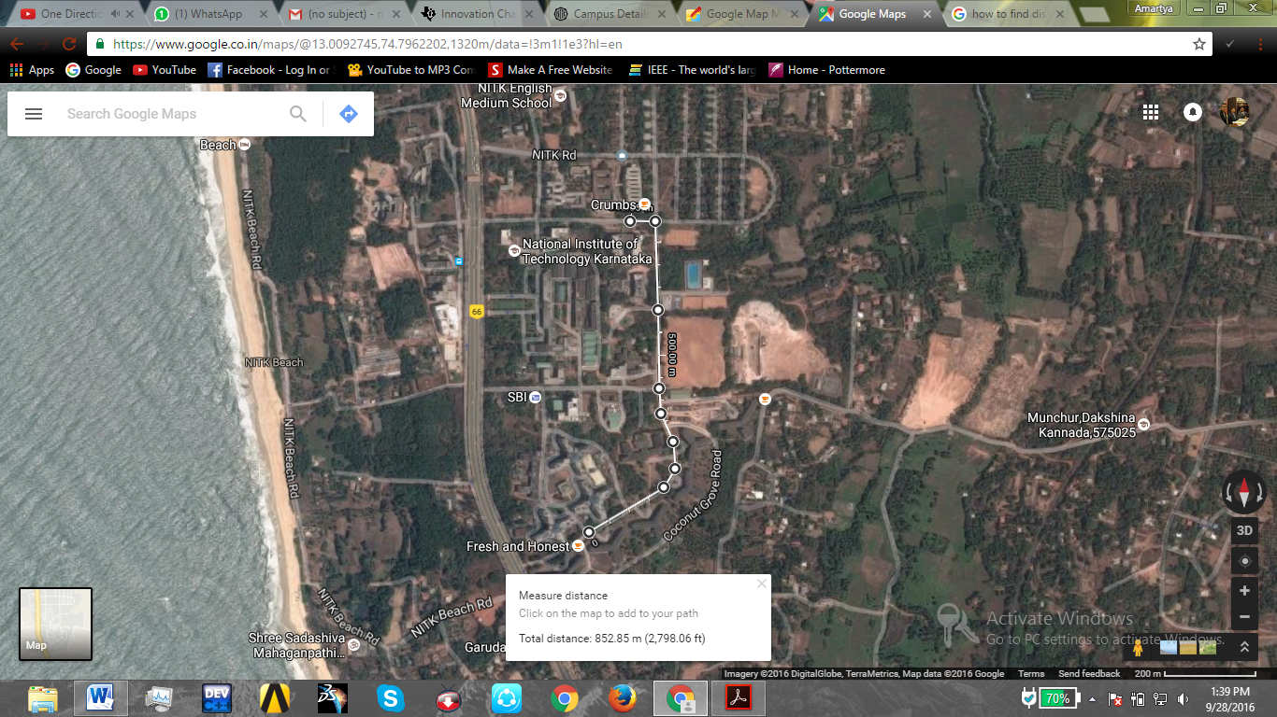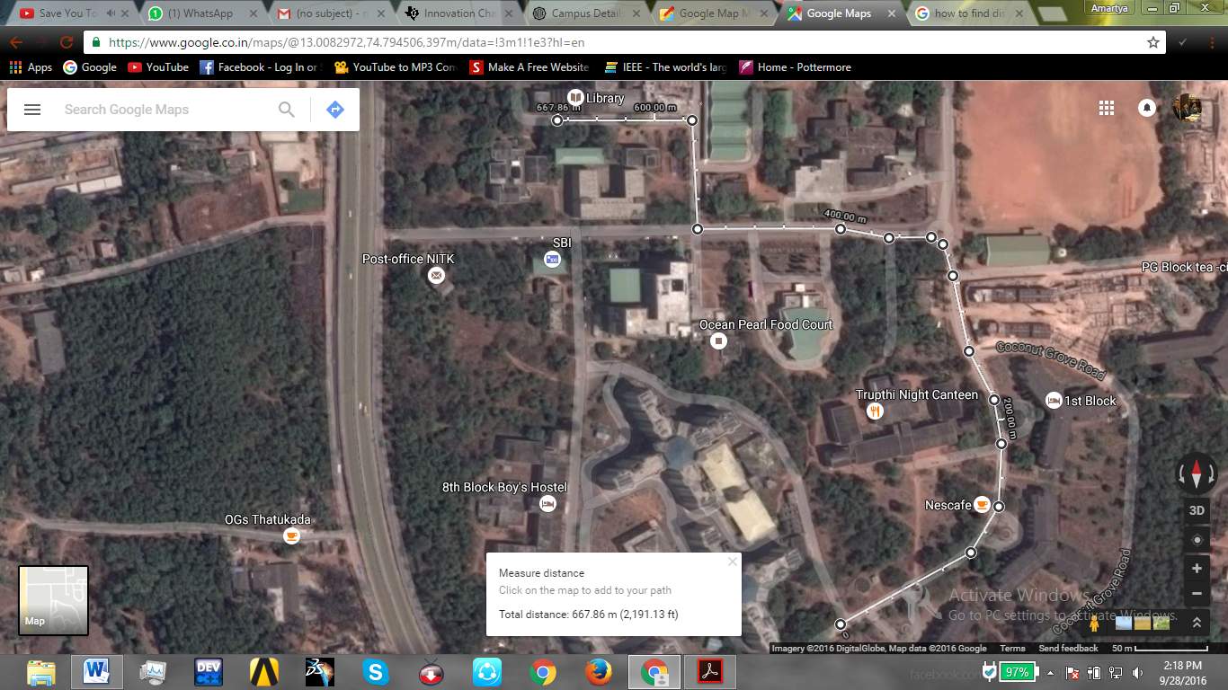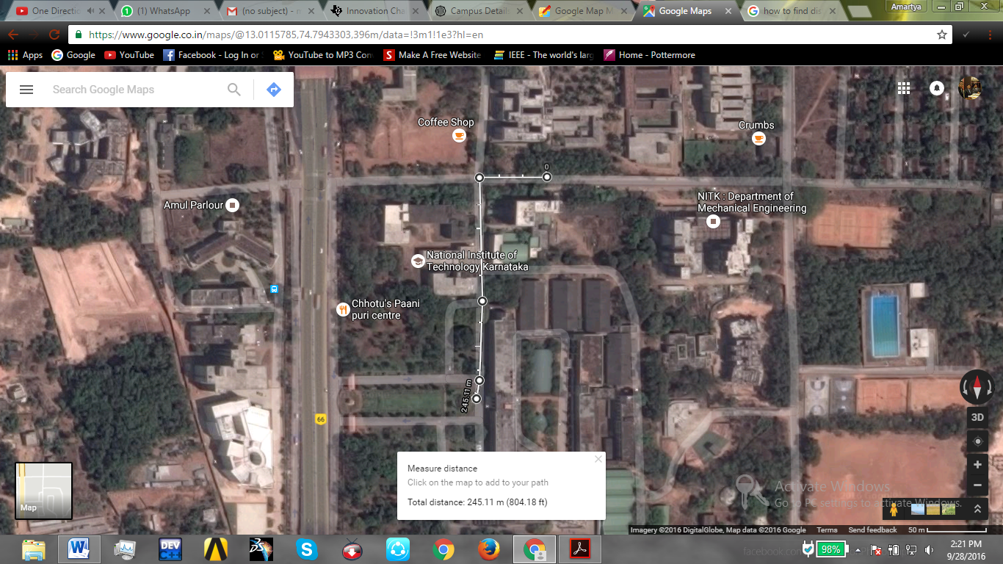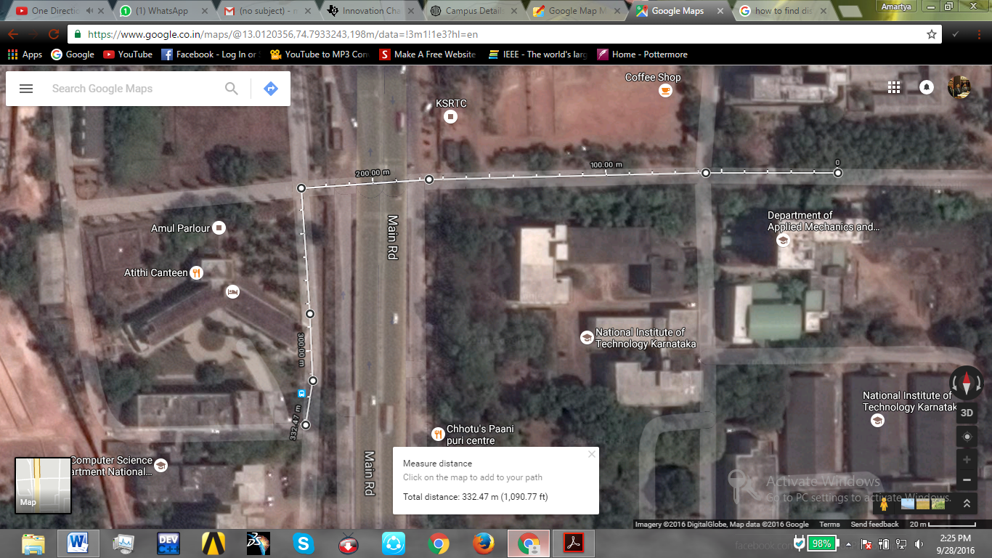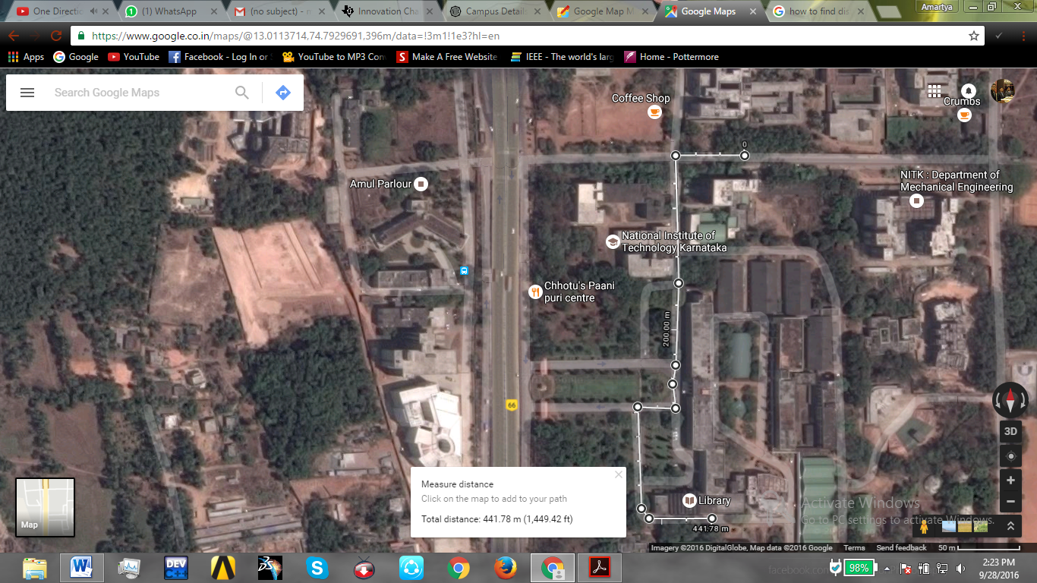

Huge campus spread over 295.35 acres. Entire campus is sub-divided into two. The western side campus contains the computer science engineering, electrical and electronics engineering and electronics and communication departments. The main campus houses the other departments and various other student activity centers.  
 There are huge considerable distances separating the hostel blocks and the various departments of NITK and student activity centers. Combining the large distances with the hot, humid and sultry weather conditions present in the area due to its location near the sea, people need an alternative mode of transport to commute within the college.   
The most affordable form of transportation would be bicycles. It gives the right amount of comfort and maneuverability.

Average distances between (Measured using Google Maps):

* Boy’s hostel and Main building (Path 1) – 940 m (3090 ft.)
* Boy’s hostel and Main building (Path 2) - 790 m (2580 ft.)
* Boy’s hostel and Western Campus (Path 1) - 1400 m (4600 ft.)
* Boy’s hostel and Western campus (Path 2) - 1240 m (4080 ft.)
* Boy’s hostel and Mechanical department- 860 m (2810 ft.)
* Boy’s hostel and Teaching Block – 670 m (2190 ft.)
* Girls hostel and Main building- 250 m (800 ft.)
* Girls hostel and Western Campus- 340 m (1100 ft.)
* Girls hostel and Teaching Block- 450 m (1500 ft.)

1. REQUIRED FOR TRAVELING TO NEAR BY PLACES AS ROAD TRIPS  
   There is a huge interest among the students for road trips and picnics to nearby places of interest. Adventure riding is also soon catching up with the students as more and more students are planning for such trips.   
   This creates a demand for cheap transportation that provides a thrilling experience and at the same time freedom to roam around at will. A bus lacks the thrill and a cab is over-expensive for such sort of trips.  
   The students prefer to go on cycles with their friends on weekends to various places of interest.  
   Preferred places of interest for road trips and their average distances from NITK:  
   All distances are measured from main building, NITK   
   Source: Distances measured using Google Maps
2. Panambur beach – 9.7 km (6.03 mi)  
   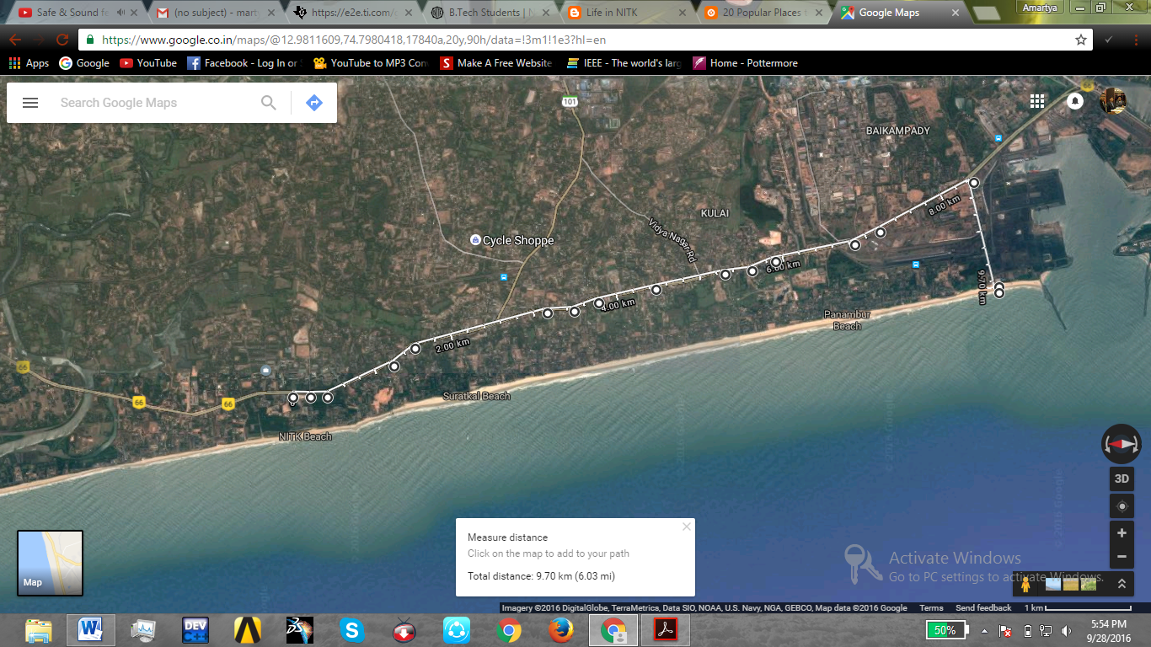  
   b) Pavanje River – 2.7 km (1.67 mi)  
   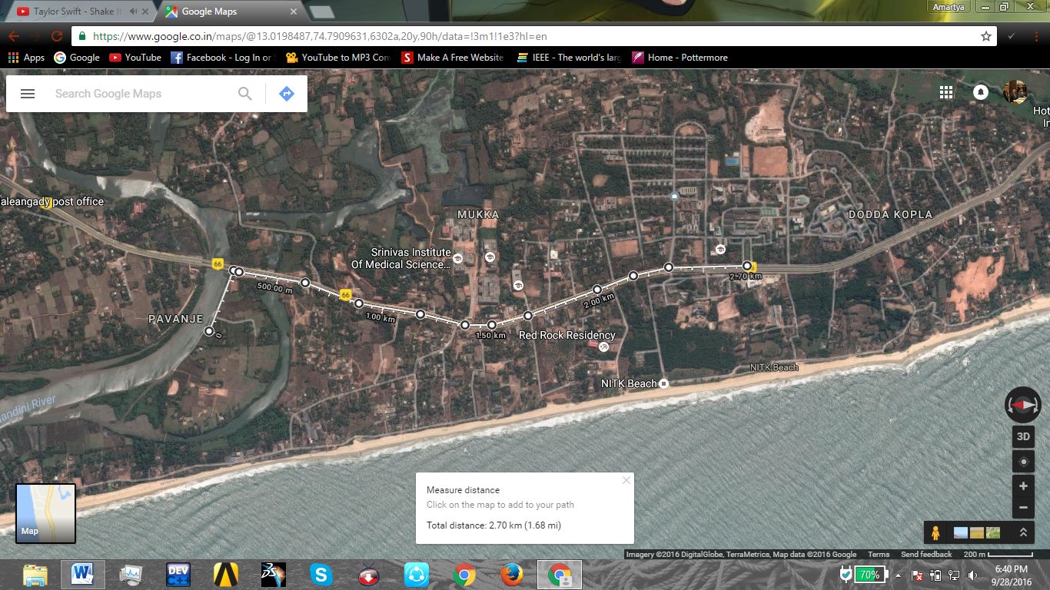  
     
     
     
     
   c) Surathkal Lighthouse – 1.46 km (4800 ft.)  
   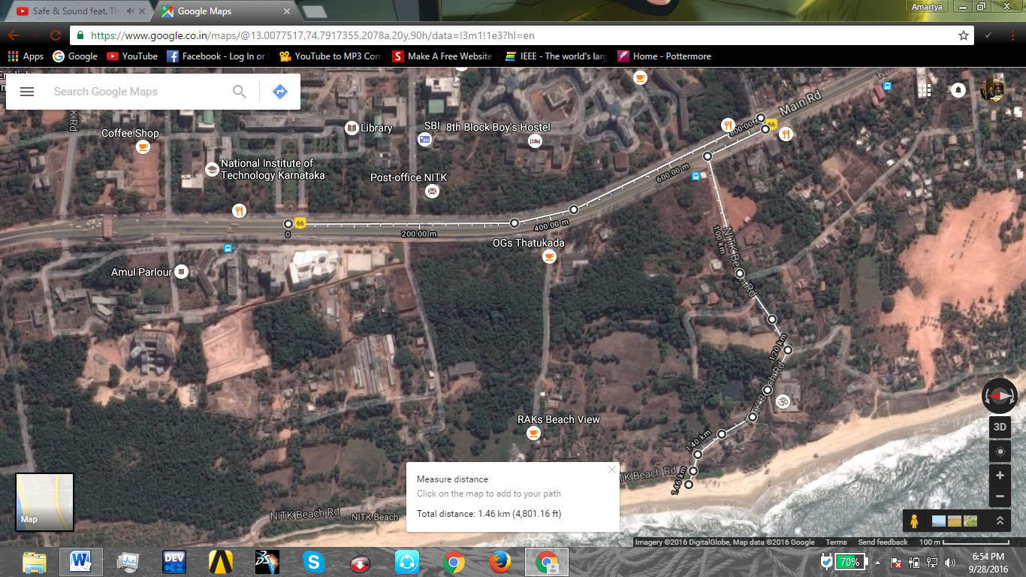  
   d) Krishnapura Muth – 5.54 km (3.44 mi)  
   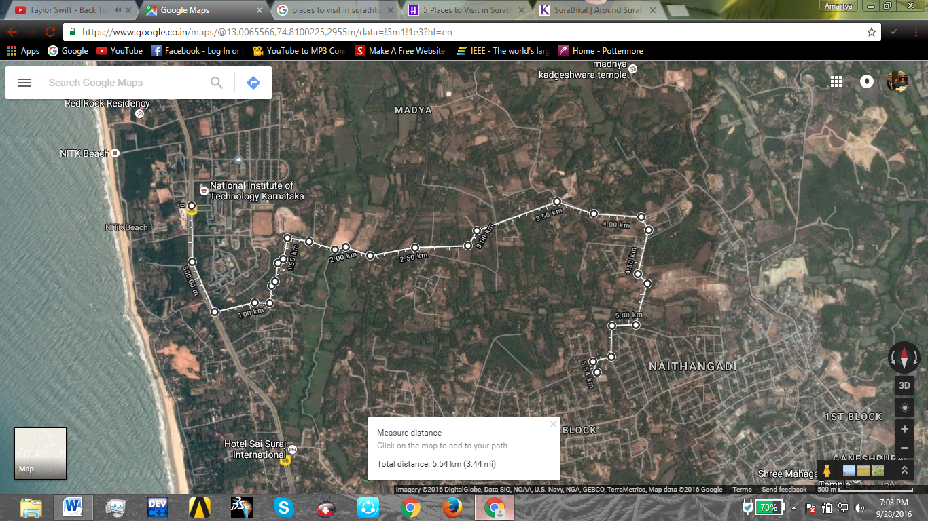  
     
     
     
     
   e) Surathkal Beach  
   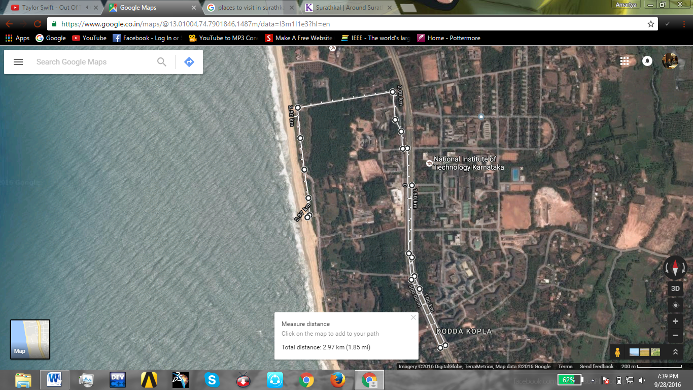
3. NEED FOR EFFICIENT, QUICK AND TIME-SAVING TRANSPORT   
   The college provides only two small buses for transportation of students within the college and that too at particular fixed timings only. This creates a problem for students who require flexibility in travelling to their departments.   
   Most of the students enjoy their sleep and have problems with waking up early enough for their classes. Hence, rushing students are a common sight within the college during the morning time. Waking up late also creates a problem for the students as they tend to miss the NITK bus service. Again an answer to this problem is a means of transport that is quick and time-saving.  
    All of this again culminates to the same point, that the majority of the students want quick and time-saving transport. And this is where we come with our cycle rental services.
4. PROMOTION OF ECO-FRIENDLY TRANSPORTATION AND GREEN LIVING  
   With the rise in concerns over global warming and climate change, eco-friendly transportation is a very important concept. We are slowly but surely using up all the resources of earth, and this creates a very bad scenario over the coming 20-30 year.  
   With this startup we plan on sensitizing people on the issue of climate change and promote a sense of responsibility in the people about these issues.